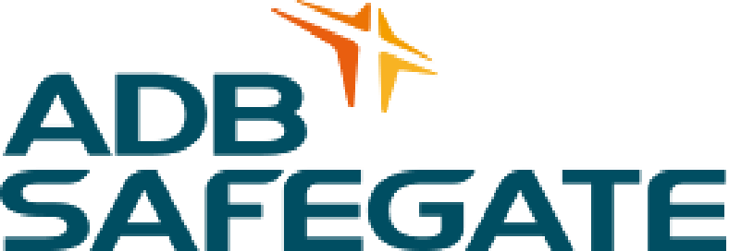 | 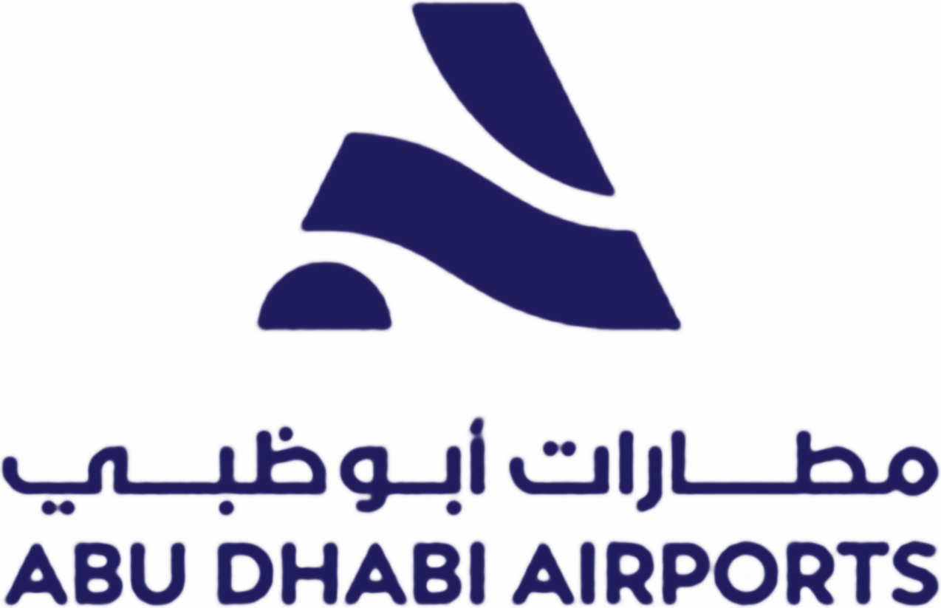

ADB SAFEGATE AGL SPARE PARTS REQUISITION
‘Abu Dhabi Airports’

Requisition Type | : | Internal
Date Requested | : | 31-Jul- 2026 | Requisition No: ADB-IR 64

S/N | ERP No. | DESCRIPTION | REQUIRED QTY | UNIT  PRICE | TOTAL  COST | REMARKS
1 | 10016966 | BASE, MOUNTING;TYP:HIGH PRESSURE INJECTION SHALLOW, DMNSN:DIA 8IN; MFR:ADB SAFEGATE,P/N:MSBC122V0003,P/N:M10;HS:85309000, W/EARTHING CONNECTION, FIXING SCREW SET, ONE SIDE CABLE (POLE QTY: 2) | 7 EA | 323.80  AED | 2,266.60  AED | 10 pcs available at ADA-D02 Warehouse
2 | 10020584 | CABLE, ELECTRICAL;CNDCTR DIA:4MM2, CNDCTR QTY:2C, VOLT RTNG:2750.1KV (1 rol/2000m) | 350 M | 7.57  AED / M | 2,649.50  AED | 1 RoL (2000 m) available at ADA-D03 Warehouse. 350 m required; balance to remain on the roll
TOTAL |  |  |  |  | 4,916.10  AED
(NOT PAYABLE)

JUSTIFICATION:

- Please be informed that we are currently experiencing shortages of certain materials, namely secondary cable and shallow bases. These materials are available in the ADA store.
- To ensure timely completion of the works within the specified closure period and to prevent any delay, we request approval to withdraw these materials through this IR. Kindly arrange for the release of these materials at the earliest.
- The materials are required for the AGL rectification works on TWY E between E4 and E6, per the final scope of work AUH-SK-AGL-TWYE-001 Rev P08.

REQUESTED BY (ADB SAFEGATE) | APPROVED BY (ADA)
Name: Ragesh Menon | Name: Ahmad Al Saafin
Signature: | Signature:
Date: | Date:

